Final Project

PROG2111

Name: Zumhliansang Lung Ler | Sungmin Leem | Nick Turco)
Course: Software Engineering Technology
Date of Submission: 30 November 2025

TABLE OF CONTENTS

Phase 1: Project Idea & Use Case 3
Project Overview 3
Phase 2: Data Modeling & ER Diagram 4
Key Entities and Attributes: 4
Key Relationships 4
ER Diagram 5
Phase 3: Normalization 6
Original Data (Unnormalized Form) 6
First Normal Form(1NF) 7
Second Normal Form(2NF) 8
Third Normal Form(3NF) 9

Phase 1: Project Idea & Use Case

Project Overview
This application is a small bookstore management system that will support various CRUD features and database queries for books and customers. We assume no co-publishing and no edge cases for simplicity.
The system will keep track of all registered customers including their names, phone number, address and email. It will also manage the individual details of each book such as title, publisher, author, stock and genre. The bookstore will manage the customer orders and the details of each order. An order will consist of a customer and order date while the order details will consist of the book, order, quantity and price. We treat publishers as direct suppliers who provide inventory to the bookstore.
Each of these entities will contain various relationships with each other through associative entities and identifiable keys.
You will be operating from the perspective of the bookstore employee, you will be able to search for customer information, orders, and books. Customers will be found by either name or customer ID. Orders will be found through order ID, and books will be found through author, genre, or title. You will be able to add and remove customers from the database, add and remove books, create new orders and update book/customer information.

Phase 2: Data Modeling & ER Diagram

Key Entities and Attributes:
1. Customer  - customerID (Primary Key)  - customerName  - customerAddress  - customerPhoneNumber  - customerEmail | 2. Book  - bookID (Primary Key)  - bookTitle  - bookISBN  - bookAuthor  - bookPrice  - bookStock  - publisherID (Foreign Key)  - categoryID (Foreign Key) | 3. OrderDetail  - detailID (Primary Key)  - orderID (Foreign Key)  - bookID (Foreign Key)  - quantity  - bookPrice
4. Category  - categoryID (Primary Key)  - categoryName | 5. Order  - orderID (Primary Key)  - orderDate  - totalAmount  - customerID (Foreign Key) | 6. Publisher  - publisherID (Primary Key)  - publisherName

Key Relationships
1. Publisher ←→ Book (1:N)
- One publisher publishes multiple books
- A book is published by one publisher
2. Category ←→ Book (1:N)
- One category contains multiple books
- A book belongs to one category
3. Customer ←→ Order (1:N)
- One customer can place multiple orders
- An order is placed by one customer
4. Order ←→ OrderDetail (1:N)
- One order can have multiple order details
- An order detail belongs to one order
5. Book ←→ OrderDetail (1:N)
- One book can appear in multiple order details
- An order detail references one book

ER Diagram
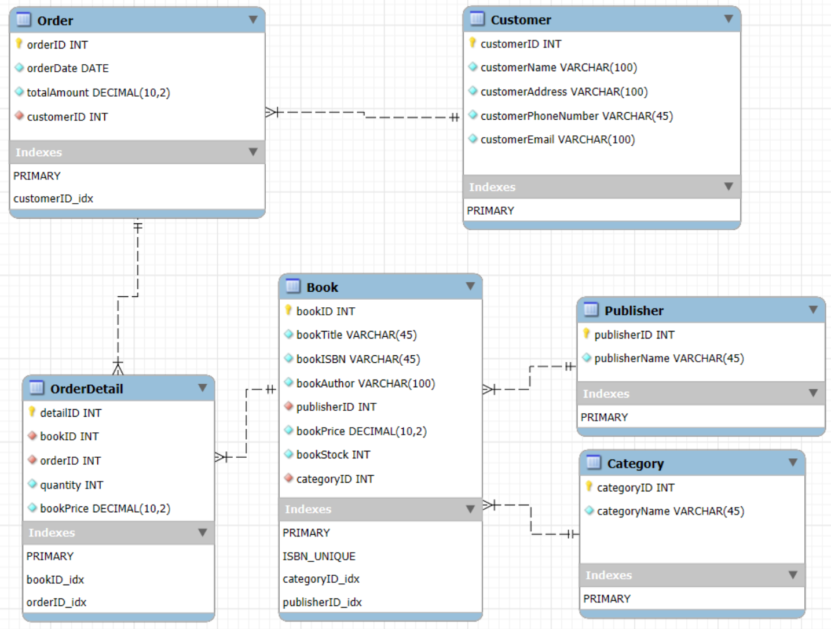

Phase 3: Normalization

Original Data (Unnormalized Form)
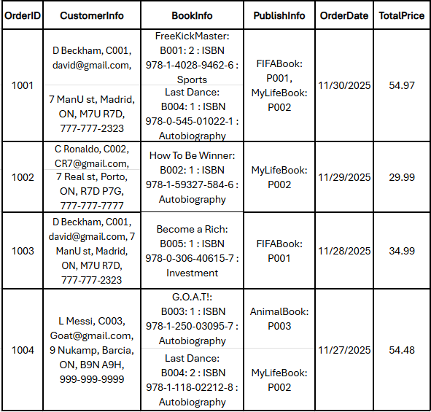
Issues and Redundancy
- Multiple Values in One Cell: The CustomerInfo column has name, ID, email, and address all together. We cannot search for just a name or email.
- Repeating Groups: The BookInfo column has multiple books separated by commas. It is hard to know how many books were sold.
- Redundancy: The same customer information (D Beckham) is repeated in rows 1001 and 1003.

First Normal Form(1NF)

Do:
- Split Information: We separated CustomerInfo into CustomerID, CustomerName, Email, Address, and Phone. We did the same for BookInfo
- Removed Repeating Groups: For Order 1001 (which has 2 books), we created two separate rows. Now, each row has only one book.

-Order
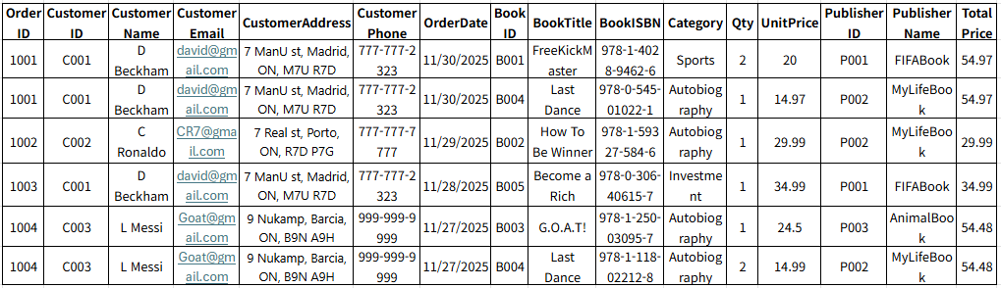

Second Normal Form(2NF)

Problem: The Primary Key is (OrderID, BookID).
- CustomerName depends only on OrderID. It has nothing to do with BookID. This is a partial dependency.
- BookTitle depends only on BookID. It has nothing to do with OrderID.
Solution: We split the table into three parts:
- Orders Table: Keeps information about the order (Customer, Date) → depends on OrderID.
- Books Table: Keeps information about the book (Title, Category, Publisher) → depends on BookID.
- OrderDetails Table: Keeps Qty because quantity depends on both Order and Book.

- Orders
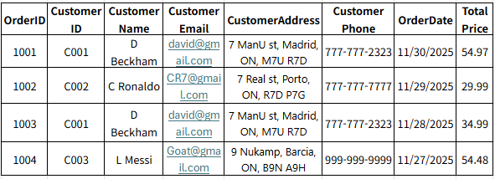

- Books
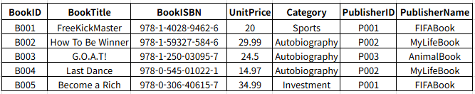
- OrderDetails
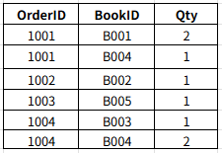

Third Normal Form(3NF)
Problem:
- In the Orders table, CustomerName depends on CustomerID, not OrderID. (OrderID → CustomerID → CustomerName). This is a transitive dependency.
- In the Books table, PublisherName depends on PublisherID, and Category (name) is repeated text.

Solution: We moved these dependent columns to their own tables.
- Created a Customer Table. Now Orders only keeps CustomerID.
- Created a Publisher Table. Now Books only keeps PublisherID.
- Created a Category Table. Now Books only keeps CategoryID.

- Customer
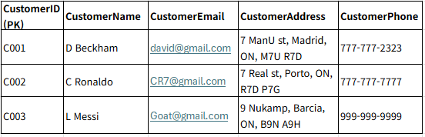

- Book
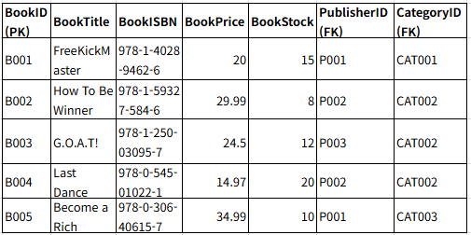

- Order
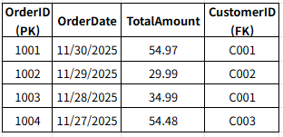

- OrderDetail
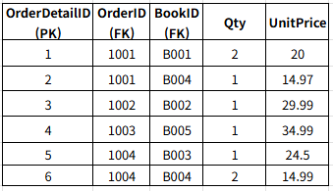

- Publisher
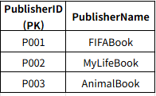

- Category
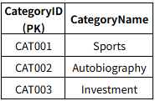

Phase 4: DDL statement
